AWAVERS RAP
AW 163 7 March 2009 www.shares-stockmarket.co.za Issue No 163
PLEASE NOTE THAT THIS INFORMATION IS FOR SUBSCRIBERS ONLY AND MUST NOT BE DISTRIBUTED OR SHOWN TO THIRD PARTIES UNDER ANY CIRCUMSTANCES.

INDEX
WEEKLY AND DAILY CHARTS
Page 2 BAROMETER | Page 3 DOW |  | Page 4 NASDAQ | Page 5 JSE INDUSTRIALS
Page 6 JSE FINANCIALS | Page 7 GENERAL MINING |  | Page 8 JSE GOLD | Page 9 JSE PLATINUM
Page 10 Metal Price Charts | Page 11 Rand / Dollar Chart |  | 12 Market Breadth
SECTORS AND SHARE WATCHLIST
Page 13 SECTORS | Page 14 WATCH LIST

Market Overview
The Dow has had its fourth consecutive “Down Week” moving into and below our Target Zone. It must also be noted that this is the sixth consecutive “Down Month”.

The DOW’s recent quick Short Term slide and the gradual and consistent downtrend has caused the Long Term (LT = Monthly Siroc 21:8) Medium Term (MT=Weekly Siroc 21: 8) Intermediate Term (IT = Daily Siroic34:13) and Short Term (ST=Siroc 13:5) to all be oversold ie below 10 at the same time ! This is an event that does not occur very often and indicates that a bottom or change in trend may not be far off. One must realize however, that a change in trend normally goes through a consolidation phase / sideways trend , as investors confidence in the markets change from negative to positive. From a technical viewpoint the bottom patterns ( eg reverse head and shoulders or double bottom et al , will form over a few weeks and only once there is a breakout from these patterns, are we likely to see a trend change that becomes sustainable. We shall be watching very closely for these patterns.

One again only Gold is performing and the $ 1000 being the bogey, as above this level we are likely to see another dynamic move in our Gold Shares. Gold has always a higher element of risk, as we saw it move from $ 1000 to $ 904 in 8 trading days ! ( 20 Feb to 4 Mar 09). Watch your Gold charts carefully and manage your positions closely and you will reap the rewards, as we have since our BUY signals in December 2008.

We are still in WAIT MODE, BUT do not distance yourself form the market , as this is probably the most important time to stay focused as you want to ensure you make the best of the opportunities once they occur.

REMEMBER THE GOLDEN RULE :
WE LOOK AT WEEKLY CHARTS TO DETERMINE THE MAJOR TREND THEN USE THE DAILY CHARTS TO TIME YOUR ENTRY AND EXIT POINTS

SECTORS

The basic top down approach means the identification of Strong sectors to invest in and the avoidance of the Weak sectors.
- The Dow and Nasdaq are analysed to get an idea of how they are performing as the have an influence on the JSE.
- Then I have used specific parameters to identify the sectors on the JSE . Sectors that are not on the Strong or Weak listing did not meet all the parameters tested. It is likely that those sectors are consolidating and will appear on one of the lists, as the sector moves in a specific direction.
- The sectors are identified using the closing value on a Friday.
- The ranking of sectors is based on their performance over the last 20 trading days

WATCH LIST

This is a Watch list not a Buy list. Confirmation analysis must be completed before deciding to buy the shares.
- The parameters used are based on the Friday closing price.
- The parameters used are designed to pick a medium term trend signal.
- Check the Daily data to establish an entry point based on the indicators you use.
- A good buying level is normally on a pullback to a Trend line, Daily MA 21 or MA 55 in conjunction with confirmation with oscillator and momentum indicators, at a Pivot Low.
- The major trends will be identified, however unfortunately, no system will pick a trend correctly 100 % of the time.
- Once the share is identified for the first time you must keep monitoring it as it may:
- keep reappearing on the list
- be removed from the list which does not mean an automatic sell, as the trend may still be intact and is
- consolidating for its next move ( and perhaps only 1 parameter scanned failed )
- If a share is on the watchlist, the first date reflects the date of the trend signal ie the date it first appeared on the watchlist. The date is generated by the Proprietary Indicator ie Weekly Siroc 21:8.
Each week I complete my scans and if the share “passes” every single parameter tested every single week since the “Trend Signal Date” , it remains on the watchlist and is in a HOLD position

TRENDS REFERRED TO IN AWAVERS NEWSLETTERS
LT – Long Term Trend > Duration Months to Years (6 months to about 4 years) -Typically Monthly Siroc 21:8
MT – Medium Term trend > Duration Months (1 to 6 / 12 months ) - Typically Weekly Siroc 21:8
IT - Intermediate Trend > Duration Days to Months (1 to 13 weeks ) - Typically Daily Siroc 34 : 13
ST – Short Term Trend > Days (1 to 15/40 days ) - Typically Daily Siroc 13 : 5

 | MEDIUM TERRM
 | BULL BEAR BAROMETER
 | Month | % | %
 | End | Bull | Bear
 | 07-Mar-09 | 17 | 83 | Bear / Downward trend
 | Feb-09 | 23 | 77 | Bear / Downward trend
 | Jan-09 | 42 | 58 | Market Risk High
 | Dec-08 | 54 | 46 | Bull % increasing
 | Nov-08 | 30 | 70 | Bear / Downward trend
 | Oct-08 | 10 | 90 | Bear / Downward trend
 | Sep-08 | 37 | 63 | Bear / Downward trend
 | Aug-08 | 55 | 45 | Bull % increasing
 | Jul-08 | 30 | 70 | Bear / Downward trend
 | Jun-08 | 10 | 90 | Bear / Downward trend
 | May-08 | 38 | 62 | Bear / Downward trend
 | Apr-08 | 30 | 70 | Bear / Downward trend
 | Mar-08 | 32 | 68 | Bear / Downward trend
 | Feb-08 | 39 | 61 | Bear / Downward trend
 | Jan-08 | 6 | 94 | Bear / Downward trend
 | Dec-07 | 30 | 70 | Bear / Downward trend
 | Nov-07 | 30 | 70 | Bear / Downward trend
 | Oct-07 | 57 | 43 | Bull % increasing
 | Sep-07 | 45 | 55 | Relief Rally
 | Aug-07 | 21 | 79 | Bear/Downward Trend
 | Jul-07 | 32 | 68 | Bear/Downward Trend
 | Jun-07 | 41 | 59 | Market Risk High (Downward gaining momentum)
 | May-07 | 69 | 31 | Upward trend (momentum slowing)
 | Apr-07 | 83 | 17 | Upward trend
 | Mar-07 | 74 | 26 | Upward trend
 | Feb-07 | 78 | 22 | Upward trend
 | Jan-07 | 84 | 16 | Upward trend
 | Dec-06 | 82 | 18 | Upward trend
 | Nov-06 | 83 | 17 | Upward trend
 | One can see how quickly the market can change and it is important to react to the signals according to your profile.
 | This barometer is based on Medium Term Parameters using selected shares from the Major Indicies on the JSE
 | Explanations
 | Above 75 % |  |  | Bull Trend / Upward Trend
 | Below 40 % |  |  | Bear Trend / Downward Trend
 | Below 50 % > then move up |  |  | Bull % increasing
 | Below 60 % > then move up |  |  | Buy with caution (Outperform)
 | Above 70 % > then fall below |  |  | Momentum slowing
 | Above 50 % > then fall below |  |  | Market Risk High

DOW – Weekly Chart
TRENDS
LT – Down
MT – Sideways / Down

INDICATORS
Siroc – Oversold.
Parabolic – Bearish WE 20Feb 09
MA 21 – Price Below > 20 %
DMI – Downward
Strategy 21:21 Negative

RELATIVE STRENGTH
MT – Underperform vs Nasdaq
ST - Underperform vs Nasdaq

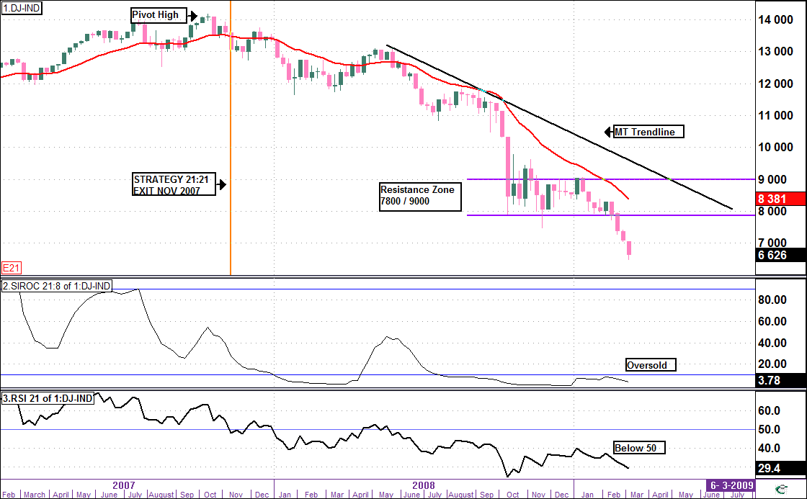
End

Daily Chart

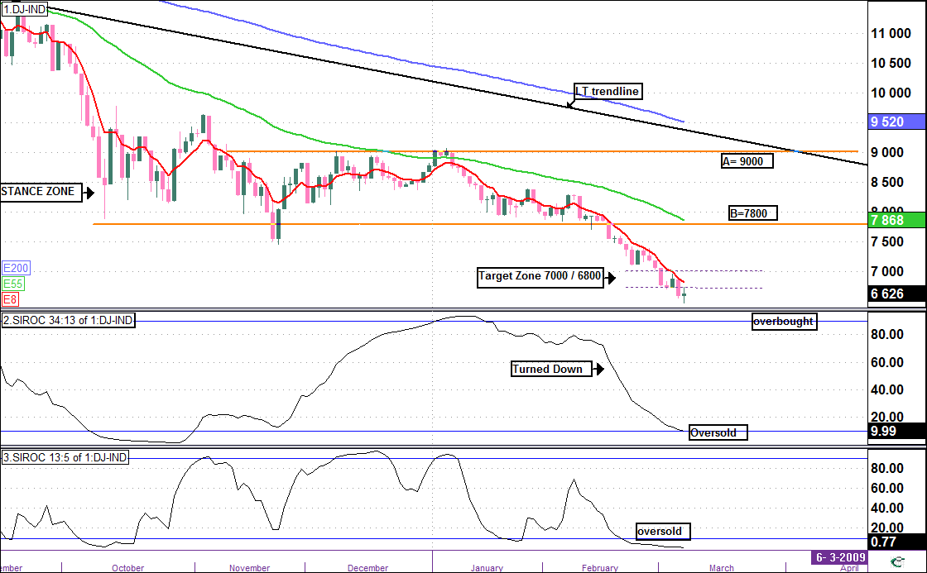
End
Analysis
MT Trend – Weekly Siroc 21:8 – Below 10 and weak (oversold)
IT Trend - Daily Siroc 34:13 – Turned Down (oversold)
ST Trend - Daily Siroc 13:5 – Below 10 and weak (oversold)

View
This is the fourth consecutive “down week” for the DOW.
Currently we see that the 3 Siroc’s in different time frames are oversold. This is an indication that a rally is likely to occur at any time.
The IT Siroc 34:13 has just moved into oversold territory, suggesting that there is a possibility of consolidation / downside before the rally gains any momentum.
The DOW is extremely vulnerable at the moment and a break below 6400 will see a test of 6000.
Once the rally gets underway it will run into resistance firstly between 7000/6800 then at trendline B and the MA 55.
WAIT AND STAY OUT

NASDAQ – Weekly Chart

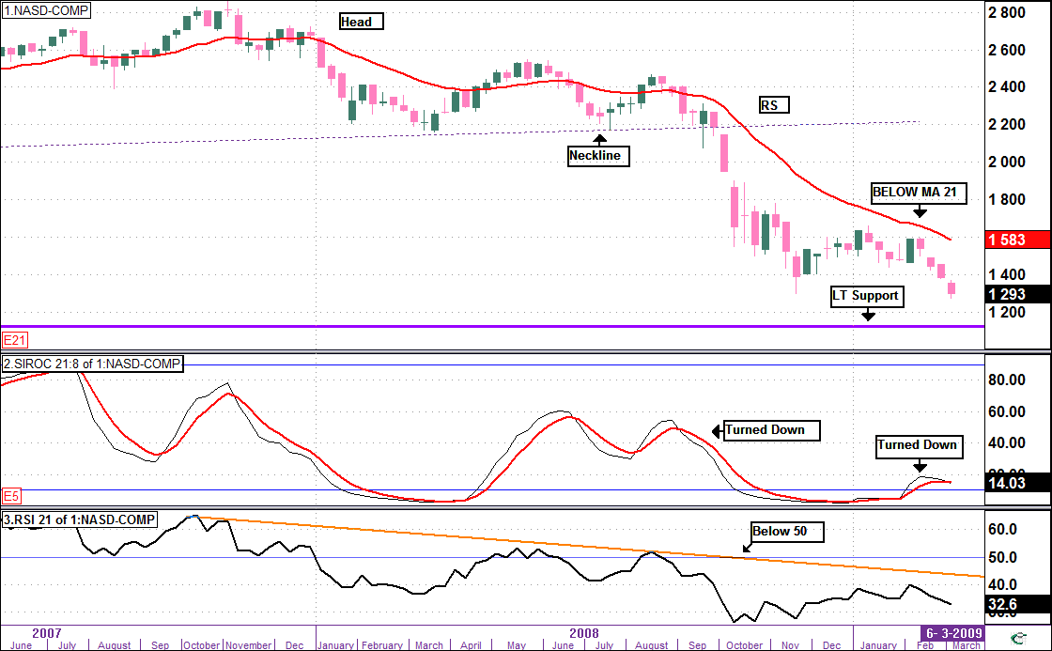
TRENDS
LT – Down
MT – Sideways

INDICATORS
Siroc – Turned Down.
Parabolic – Bearish WE 6Mar 09
MA 21 – Price Below > 18 %
DMI – Downtrend
Strategy 21:21 Negative

RELATIVE STRENGTH
MT = OutPerform vs Dow
ST = Outperform vs Dow

End

NASDAQ – Daily Chart

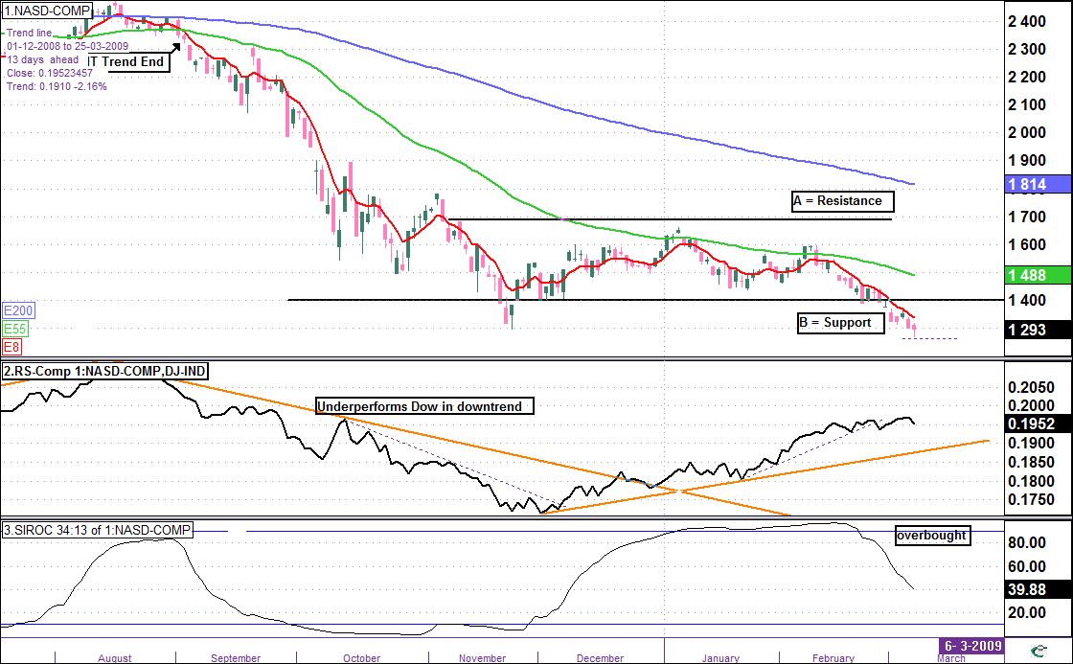
End
Analysis
MT Trend – Weekly Siroc 21:8 – Turned Down (Aborted)
IT Trend - Daily Siroc 34:13 – Falling (Negative – turned down)
ST Trend - Daily Siroc 13:5 – Oversold – (Neutral)
View
The Nasdaq fell quickly to 1300 (and below) per AW 162, as the Siroc 34:13 moved below 90 and the Nasdaq started underperforming the Dow . The Siroc 34:13 still has space to move down suggesting a consolidation / downside in the IT.
Any rally is likely to find resistance at trendline B , the previous support level
WAIT AND STAY OUT

JSE INDUSTRIALS – Weekly Chart
TRENDS
LT– Down
MT – Sideways / Down

INDICATORS
Siroc – Sell Alert .
Parabolic - Bearish WE 27Feb 09
MA 21 – Price Below lag > 13 %
DMI – Downward Strengthening
Strategy 21:21 Negative

RELATIVE STRENGTH
MT – Neutral vs JSE All Share
ST – Underperform vs JSE AllShare

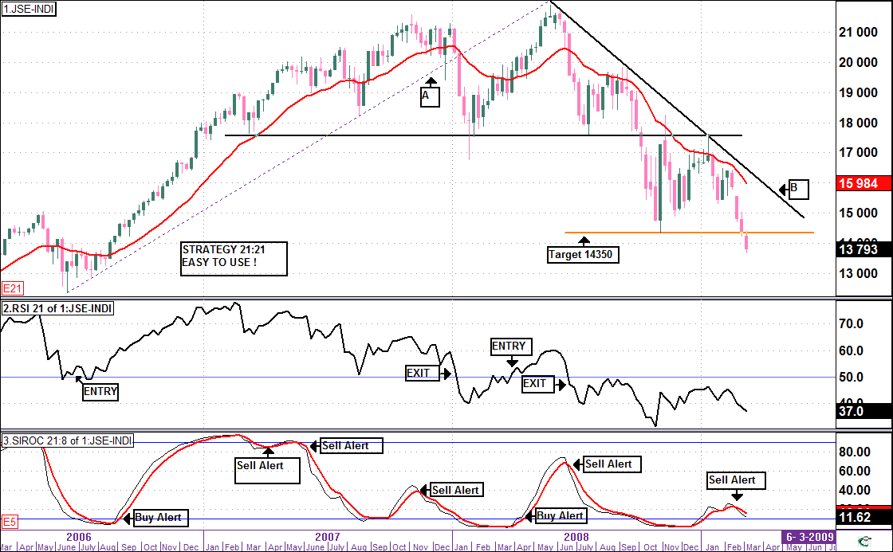
End

Daily Chart

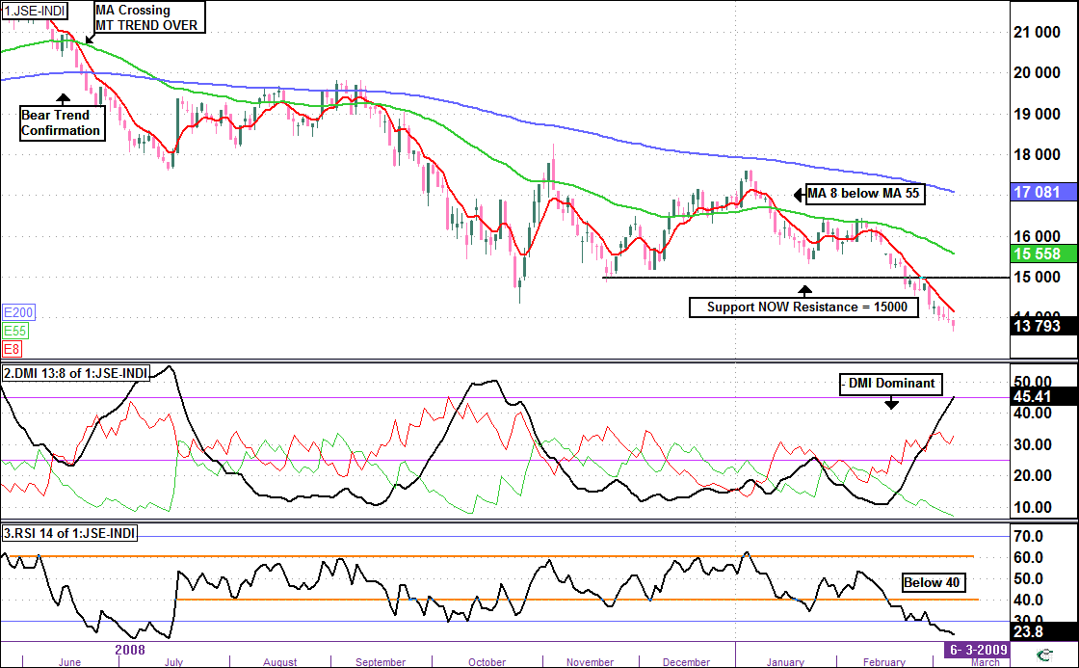
End
Analysis
TRENDS > MT Weekly Siroc 21:8 - Turned Down giving Sell Alert (negative)
> IT Daily Siroc 34:13 - Below 10 (oversold)
> ST Daily Siroc 13:5 - Below 10(oversold )
Targets / Support / Resistance
Our this target of 14 350 was tested and breached as expected but has not yet achieved the target of 13 540 per AW 162
Support at 13540 and Resistance at 15000 then MA 55.
View
MOST IMPORTANTLY, the MA 8 remains below the MA 55 confirming the MT downtrend intact.
The – DMI above + DMI confirms Bears dominant and RSI 14 has moved below 30 and is oversold.
There is likely to be a rally from these oversold conditions at any time, however the previous support at 15 000 is now a resistance level with the next resistance at the MA 55. The market is vulnerable and I am not ruling out a lower lows before (or after ) any rally.
WAIT AND STAY OUT

JSE FINANCIALS – Weekly Chart

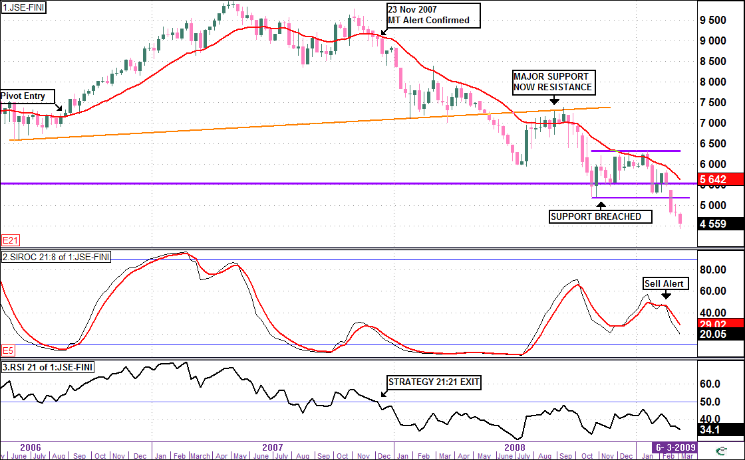
TRENDS
LT – Down
MT – Sideways / Down

INDICATORS
Siroc – Turned Down (Negative)
Parabolic – Bearish 23Jan 09
MA 21 – Price below lag > 19 %
DMI – Downtrend Dominant
Strategy 21:21 Bearish

RELATIVE STRENGTH
MT – Underperform vs JSE ALSH
ST – Underperform vs JSE ALSH

End

Daily Chart

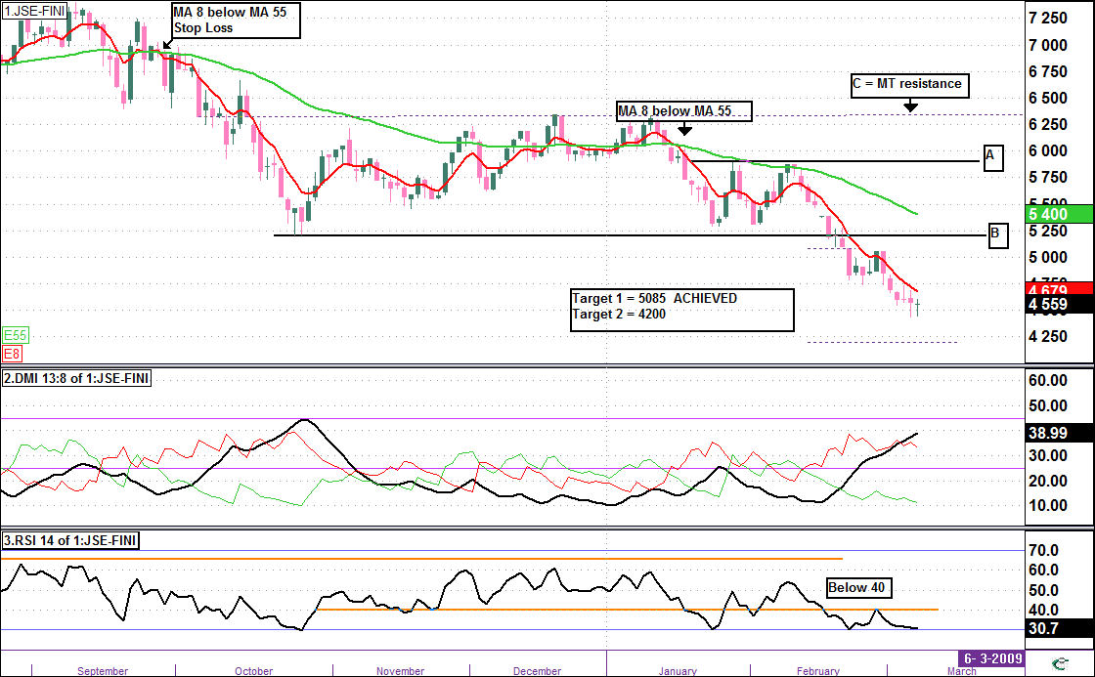
End
Analysis
TRENDS > MT Weekly Siroc 21:8 Sell ALERT falling towards oversold
> IT Daily Siroc 34:13 Below 10 (oversold)
> ST Daily Siroc 13:5 Below 10 (oversold)
Targets / Support / Resistance
The next downside target is 4200.
Support at 4200 and Resistance at B then MA 55
View
There is likely to be a rally from these oversold conditions at any time, however the previous support at 5 200 is now a resistance level, with the next resistance at the MA 55. The market is vulnerable and I am not ruling out a lower lows before (or after ) any rally.
WAIT AND STAY OUT

JSE GENERAL MINING – Weekly Chart
TRENDS
LT – Down
MT – Sideways / Down

INDICATORS
Siroc – Turned up from below 10.
Parabolic – Bearish 23Jan 09
MA 21 – Price Below lag > 12 %
DMI – Negative
Strategy 21:21 Negative

RELATIVE STRENGTH
MT - Neutral VS JSE AllShare
ST – Neutral VS JSE AllShare

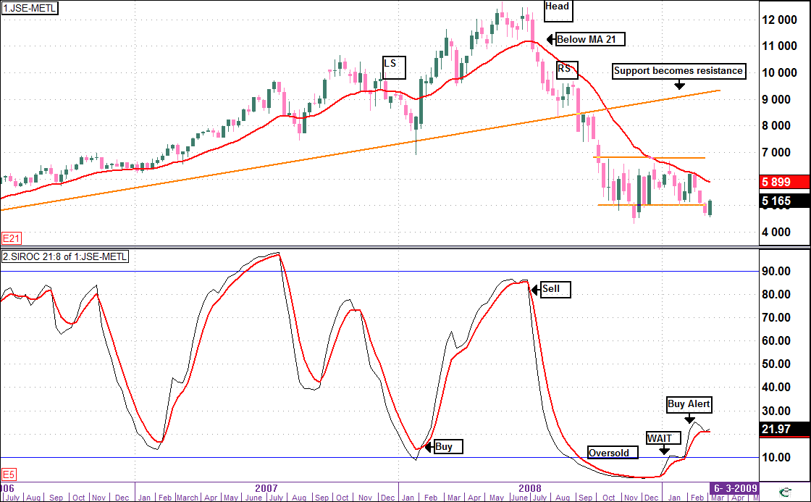
End

Daily Chart

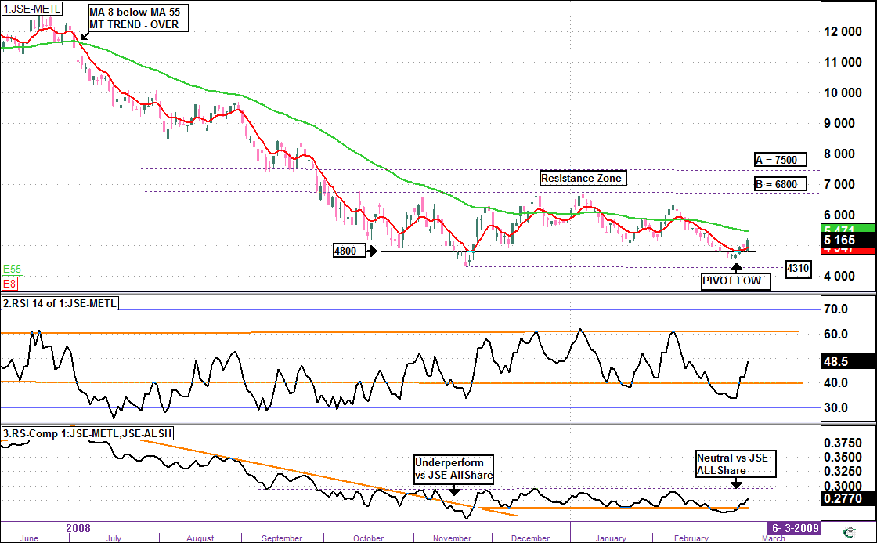
End
Analysis
TRENDS > MT Weekly Siroc 21:8 Turned Up from below 10 (positive)
> IT Daily Siroc 34:13 Flattening at neutral level (neutral)
> ST Daily Siroc 13:5 Rising from below 10 (ST rally to continue)
Targets / Support / Resistance
The 4800 level was tested as per AW 162 and slightly exceeded but has bounced back to close at 5165 on Friday.
Should a breach 4800 occur again, the target is the previous low at 4310 and with the risk of further falls to 4200.
Resistance at MA 55 then Trendline B at 6800
View
Our proprietary indicator is positive (Weekly Siroc 21:8) but confirmation evidence required.
The Low on the 3 Mar 09 of 4551 was lower than the January 09 low, so for any sustainable upward momentum, the Index must consolidate above the Feb high of 6294 (say 6300) AND the MA 8 must cross and remain above the MA 55.
To confirm the RSI 14 must move above 60 and the Index needs to outperform the JSE ALLSHARE
WAIT AND STAY OUT - Will keep you posted as we will be monitoring closely.

JSE GOLD – Weekly Chart
TRENDS
LT – Breached to Upside(since Jan 06)
Hint Check Monthly Siroc 21:8
MT – UP

INDICATORS
Siroc – Buy Alert 28 Nov 08
Parabolic – Bullish WE 28 Nov 08
MA 21 – Price Above > 28% (high)
DMI – Upward dominant
Strategy 21:21 Positive

RELATIVE STRENGTH
LT -Underperforming Gold Zar AND
MT – Outperform VS Gold Zar
ST – Neutral VS Gold ZAR

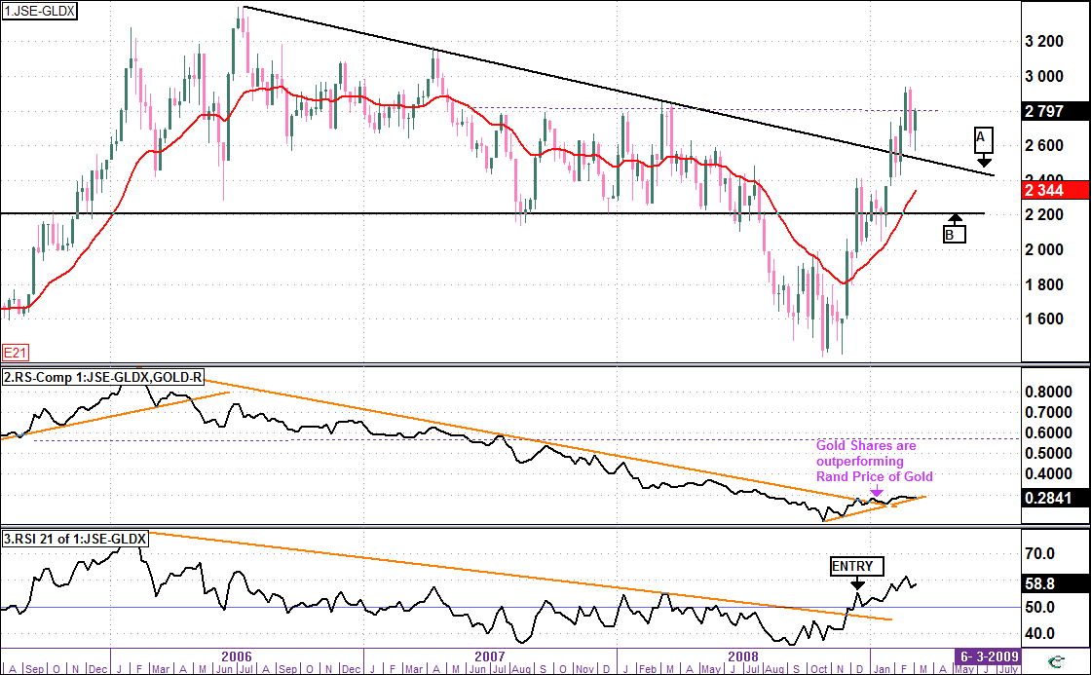
End

Daily Chart

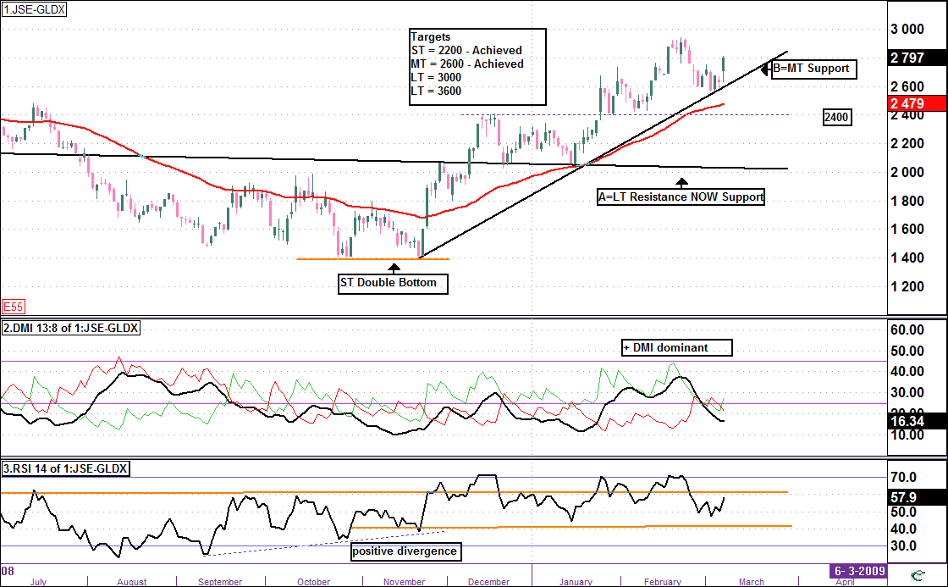
End
Analysis
The Weekly charts are positive AND has now breached the LT resistance trendline A and closed near 2800.
- The Targets per AW 158 dd 6 December 08 of 2200 and 2600 have now both been achieved. (3000 almost achieved !!)
Looking at the daily chart :
- The Gold Index has moved up through Resistance (A = 2000 level) and is consolidating above this level.
- The next support is at Trendline B , MA 55 and 2400 which are close to each other and providing triple support, so any breach of these levels, will alert us that there is likely to be downside towards Trendline A.
- + DMI is above – DMI indicating Bulls are dominating BUT ADX is below 25 indicating that the Gold Index Trend is consolidating before its next move.
- A strong move looks likely next week towards 3000 (and beyond)
Targets / Support / Resistance
Support at Trendline B and support zone between 2400 and 2300.LT resistance trendline at A now becomes a support trendline.
Targets on a break above 2000 = ST 2200 (ACHIEVED) and MT 2600 (ACHIEVED).Longer term targets are 3000 then 3600
View
The Gold index pullbacked towards B / MA 55.(as expected) .Continue buying on pullbacks at Pivot Lows near trendline B
Stop Loss
Alert MA 8 below MA 21 / breach trendline B. Stop at 2 consecutive closes below MA 55.

JSE PLATINUM – Weekly Chart

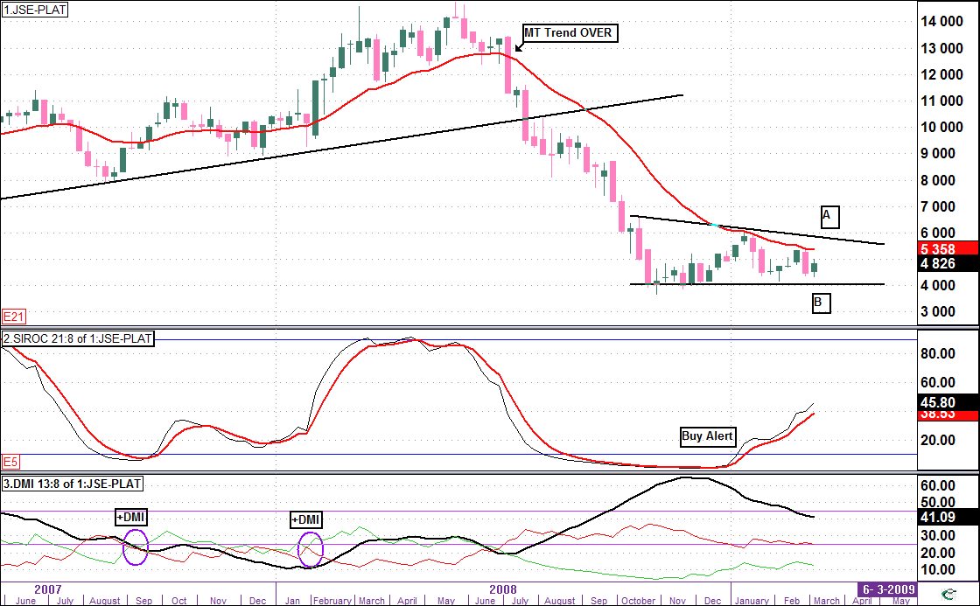
TRENDS
LT – Down
MT – Sideways

INDICATORS
Siroc – Turned up (Positive).
Parabolic – Bearish 23Jan 09
MA 21 – Price Below lag > 9 %
DMI – Downtrend Dominant

RELATIVE STRENGTH
MT – Underperform VS Rand Price Plat
ST – Underperform VS Rand Price Plat

Note Weekly Chart (Bottom Panel)
The trend gained momentum when +DMI crossed – DMI in past but currently has not yet crossed
End

Daily Chart

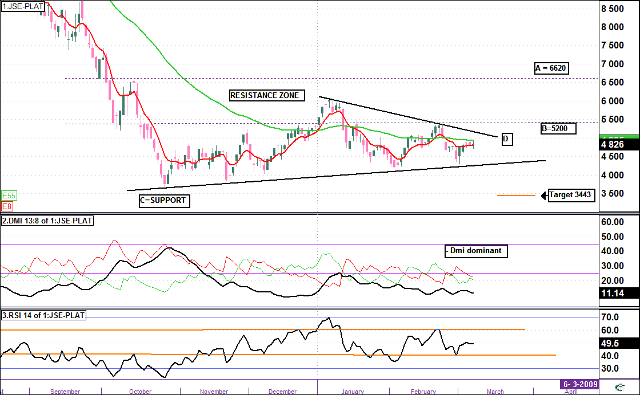
End
TRENDS > MT Weekly Siroc 21:8 Turned Up above 10 (Positive)
> IT Daily Siroc 34:13 Overbought (above 90 and flattening - neutral)
> ST Daily Siroc 13:5 Rising from neutral position and weak
Targets / Support / Resistance
Downside target on a breach below C is 3443. Upside break above 5500 is required before any probability of upside momentum.
Support at trendline C then 4000 and Resistance at MA 55 then resistance Zone between A and B.
View
MA 8 whipsawed below the MA 55 indicating uncertainty ( sideways trend)
The ST pullback per AW 162 is in progress.
The RSI 14 could not breach 60 but needs to remain above 40 to hold above support C
A break below C and RSI 14 below 40 will see downside towards the target of 3443.
WAIT for Now as the trend is directionless and we have to wait for a breakout (either way !)

METAL PRICES > GOLD PRICE – Daily Chart

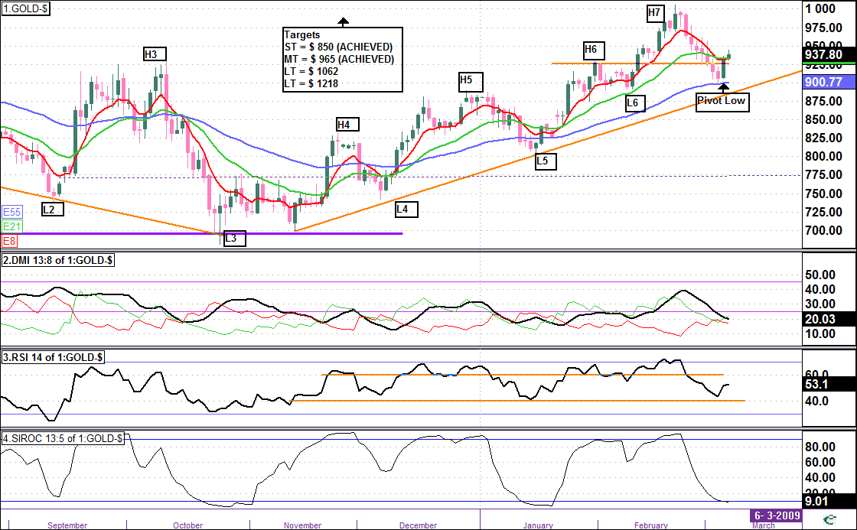
End
Comment
The $ Gold Price is in a solid uptrend and the ST Siroc 13:5 is oversold after a stong pullback towards the MA 55.
+ DMI must remain above – DMI and above 25 for any rally to attack $ 1000
Watch the RSI 14 as :
- Above 70 we are likely to breach $ 1000.
- Below 40 are likely to see a significant pullback.
The RSI 14 - As long as it frequently moves above 60 and finds support at 40, the MT trend will stay intact.
Targets are MT $ 965(Achieved) then LT $1062 and $1218

PLATINUM $

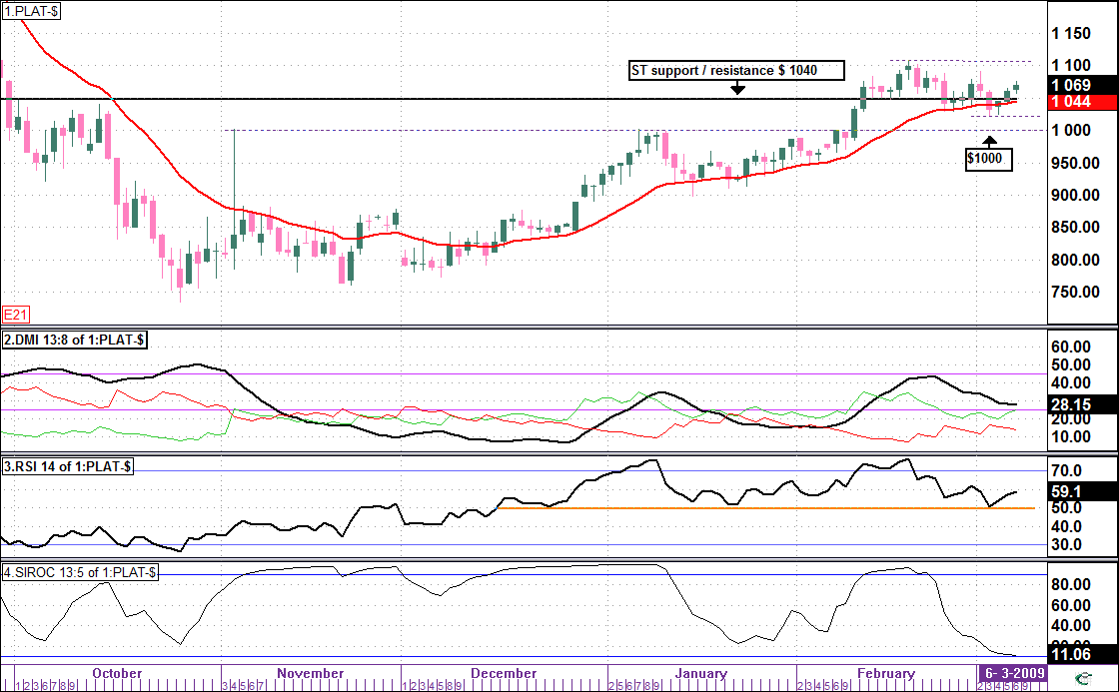
End
Comment
The Siroc 13:5 alerted us of the pullback as per AW 162.
The RSI 14 is looking weak and needs to stay above 40 level for the $ 1000 level to hold.
The + DMI also needs to remain above – DMI to prevent downside below $ 1000
Platinum is likely to consolidate between $ 1100 and $ 900 in the MT.
A breakout above $1100 has a target 0f $ 1180.

RAND / DOLLAR – Daily Chart

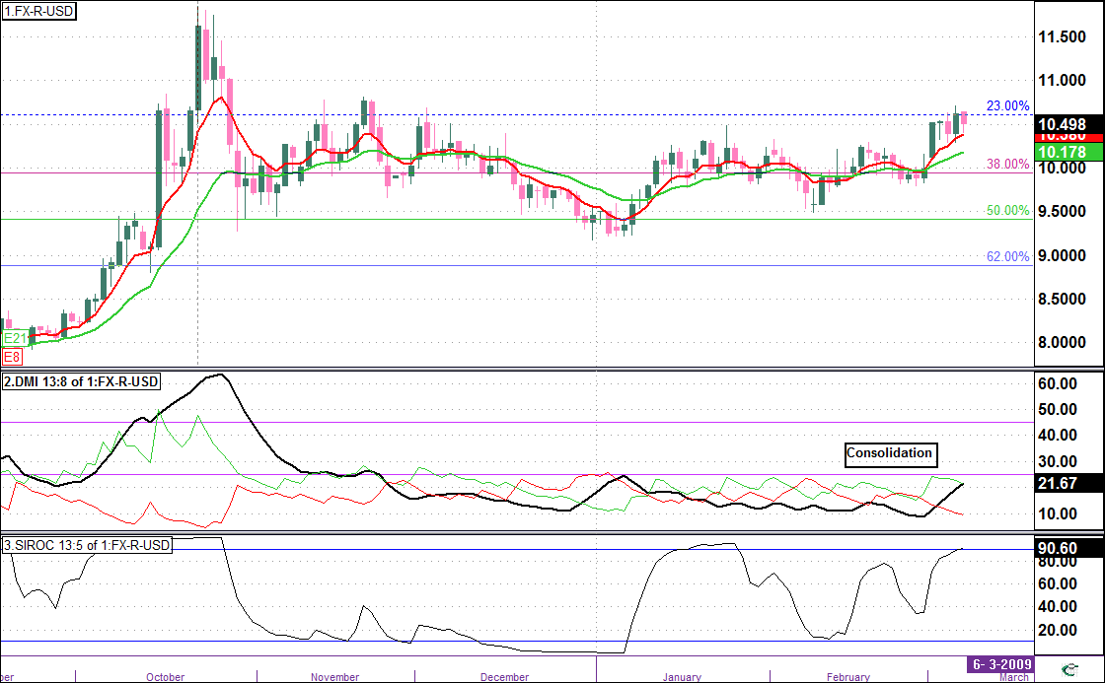
End

The Primary trend of Rand / Dollar is NEUTRAL / BIAS towards weakness

Currently we see …
- The rand has been consolidating between 1050 and 950 .
- DMI is directionless as all the lines are below 25
- Risk of further weakness towards 1100

MARKET BREADTH

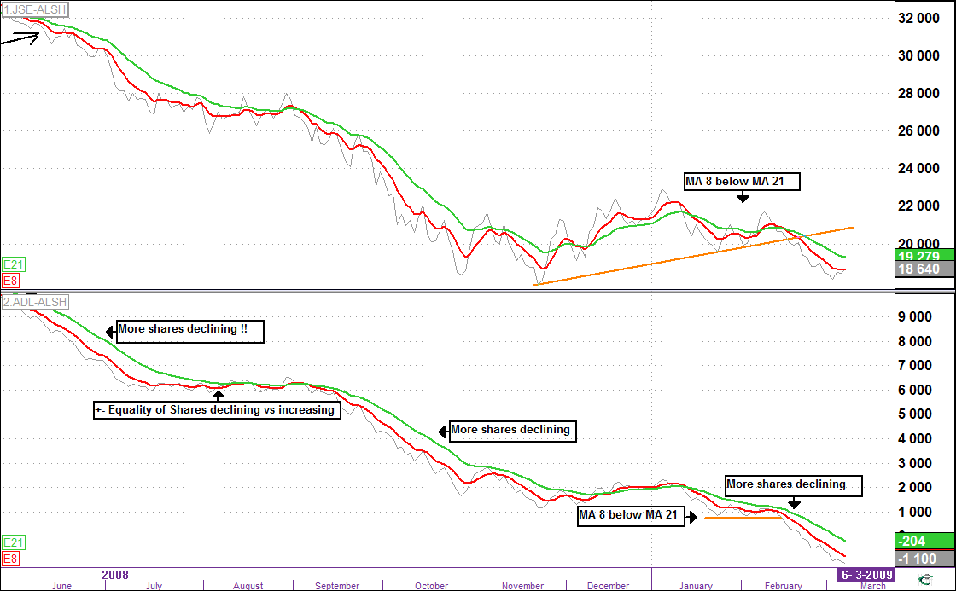
End

Market Breadth ( Market Master Sector Codes , Item no 16 )

The Advance/Decline Line (ADL-in Market Master") is a widely used measure of market breadth. It is a cumulative total of the Advancing less the Declining shares in an Index. When compared to the movement of that actual index the A/D Line has proven to be an effective gauge of the stock market's strength.
When more stocks are advancing than declining, the A/D Line moves up. When more stocks are declining than advancing, the A/D Line moves down.

Over the last few months we have seen predominantly more shares declining than advancing..

We saw a short Xmas rally when more shares were increasing, then we saw some consolidation from mid Jan09 to mid Feb 09 as the chart was flattening, indicating about the same number of shares declining as increasing.
In the last 4 weeks however the trend of more shares declining than increasing has returned, as the JSE AllShare also breached the ST support trendline to the downside..

DATE | 06-Mar-09
 | % = Growth / Fall of sector in last 20 trading days
 |  |  |  | Name | LongName
 | STRONG SECTORS |  |  | JSE-ALSH | FTSE/JSE All Share
Rank |  | Rise % |  | JSE-AUTM | FTSE/JSE Automobiles & Parts
 | Share | Actual |  | JSE-BANK | FTSE/JSE Banks Index
 |  |  |  | JSE-BEVR | FTSE/JSE Beverages Index
1 | JSX:JSE-GLDX | 11.88% |  | JSE-CHES | FTSE/JSE Chemicals Index
2 | JSX:JSE-PHAR | 0.67% |  | JSE-COAL | FTSE/JSE Coal
3 | JSX:NEWGOLD | 9.22% |  | JSE-CONM | FTSE/JSE Construction & Materials Index
 |  |  |  | JSE-DIAM | FTSE/JSE Diamonds & Gemstones
 | WEAK SECTORS |  |  | JSE-ELEE | FTSE/JSE Electronic & Electrical Equip.
 |  |  |  | JSE-EQII | FTSE/JSE Equity Investment Instruments
1 | JSX:JSE-FORE | 44.88% |  | JSE-FOOD | FTSE/JSE Food Producers Index
2 | JSX:JSE-LIFE | 27.56% |  | JSE-FOOR | FTSE/JSE Food & Drug Retailers Index
3 | JSX:JSE-INDE | 26.18% |  | JSE-FORE | FTSE/JSE Forestry & Paper Index
4 | JSX:JSE-INDT | 22.95% |  | JSE-FTEL | FTSE/JSE Fixed Line Telecommunications
5 | JSX:JSE-GENF | 22.44% |  | JSE-GENF | FTSE/JSE General Financial Index
6 | JSX:JSE-HOUS | 20.55% |  | JSE-GENI | FTSE/JSE General Industrials Index
7 | JSX:JSE-BANK | 20.27% |  | JSE-GERE | FTSE/JSE General Retailers Index
8 | JSX:JSE-SUPS | 20.17% |  | JSE-GLDX | FTSE/JSE Gold Mining
9 | JSX:SATRIX-FI | 20.17% |  | JSE-HCOM | FTSE/JSE Technology Hardware
10 | JSX:JSE-GERE | 19.93% |  | JSE-HEES | FTSE/JSE Health Care Equip. and Service
11 | JSX:JSE-TRAV | 19.61% |  | JSE-HOUS | FTSE/JSE Household Goods
12 | JSX:JSE-PERG | 17.20% |  | JSE-INDE | FTSE/JSE Industrial Engineering
13 | JSX:JSE-CHES | 15.97% |  | JSE-INDM | FTSE/JSE Industrial Metals Index
14 | JSX:JSE-BEVR | 15.77% |  | JSE-INDT | FTSE/JSE Industrial Transportation Inde
15 | JSX:SATRIXDIV | 15.74% |  | JSE-LEIS | FTSE/JSE Leisure Goods Index
16 | JSX:JSE-MTEL | 15.09% |  | JSE-LIFE | FTSE/JSE Life Assurance Index
17 | JSX:JSE-ELEE | 15.02% |  | JSE-MEDI | FTSE/JSE Media Index
18 | JSX:DBXEURO50 | 14.91% |  | JSE-MIDC | FTSE/JSE Mid Cap
19 | JSX:JSE-GENI | 14.85% |  | JSE-MTEL | FTSE/JSE Mobile Telecommunications
20 | JSX:SATRIX-IN | 14.27% |  | JSE-NLIF | FTSE/JSE Non-Life Insurance
21 | JSX:JSE-FOOR | 14.18% |  | JSE-OILP | FTSE/JSE Oil & Gas Producers
22 | JSX:DBXFT100 | 13.71% |  | JSE-PERG | FTSE/JSE Personal Goods Index
23 | JSX:JSE-TOPI | 13.45% |  | JSE-PHAR | FTSE/JSE Pharmaceuticals & Biotech.
24 | JSX:JSE-FTEL | 13.07% |  | JSE-PLAT | FTSE/JSE Platinum & Precious Metals
25 | JSX:JSE-ALSH | 13.04% |  | JSE-PRUT | FTSE/JSE Property Unit Trusts
26 | JSX:SATRIXSWX | 12.75% |  | JSE-PULS | FTSE/JSE Property Loan Stock
27 | JSX:NEW-RAND | 12.36% |  | JSE-REAL | FTSE/JSE Real Estate Index
28 | JSX:JSE-MEDI | 11.37% |  | JSE-SCOM | FTSE/JSE Software & Computer Services
29 | JSX:JSE-MIDC | 10.97% |  | JSE-SMLC | FTSE/JSE Small Cap
30 | JSX:SATRIX-40 | 10.83% |  | JSE-SUPS | FTSE/JSE Support Services Index
31 | JSX:JSE-FOOD | 9.07% |  | JSE-TOPI | FTSE/JSE Top 40
32 | JSX:JSE-SMLC | 9.06% |  | JSE-TRAV | FTSE/JSE Travel and Leisure Index
33 | JSX:JSE-REAL | 8.93%
34 | JSX:JSE-CONM | 7.69%
35 | JSX:JSE-PULS | 6.79%
36 | JSX:JSE-OILP | 6.75%
37 | JSX:JSE-PRUT | 5.62%
38 | JSX:PROPXSAPY | 5.57%

DATE | 06-Mar-09
WATCH LIST | FINANCIALS
 | TREND | SIGNAL | Latest
Share | Date | Price | Close | Change | % Change
JSX:EMIRA | 06/03/2009 | 10.40 | 10.40 | 0.00 | 0
JSX:BRIMSTN-N | 13/02/2009 | 3.56 | 4.35 | 0.79 | 22
JSX:HOSP-B | 23/01/2009 | 19.00 | 19.30 | 0.30 | 2
JSX:SANTAM | 26/12/2008 | 76.00 | 77.91 | 1.91 | 3
JSX:ERM | 12/12/2008 | 1.25 | 1.30 | 0.05 | 4
JSX:BJM | 28/11/2008 | 2.65 | 2.69 | 0.04 | 2
JSX:CONDUIT | 21/11/2008 | 0.44 | 0.62 | 0.18 | 41
JSX:MADISON | 07/11/2008 | 6.00 | 6.50 | 0.50 | 8
JSX:BRIMSTON | 05/09/2008 | 5.40 | 5.00 | -0.40 | -7
Finished Testing
WATCH LIST | INDUSTRIALS
 | TREND | SIGNAL | Latest
Share | Date | Price | Close | Change | % Change
JSX:CARGO | 06/03/2009 | 7.80 | 7.80 | 0.00 | 0
JSX:RAINBOW | 27/02/2009 | 15.00 | 14.49 | -0.51 | -3
JSX:VALUE | 06/02/2009 | 2.90 | 2.89 | -0.01 | 0
JSX:CULLINAN | 30/01/2009 | 0.45 | 0.41 | -0.04 | -9
JSX:OCEANA | 23/01/2009 | 22.99 | 25.25 | 2.26 | 10
JSX:ASPEN | 16/01/2009 | 38.95 | 43.60 | 4.65 | 12
JSX:CASHBIL | 26/12/2008 | 49.60 | 56.00 | 6.40 | 13
JSX:ILLOVO | 26/12/2008 | 23.00 | 26.38 | 3.38 | 15
JSX:TRNPACO | 26/12/2008 | 5.10 | 5.50 | 0.40 | 8
JSX:TONGAAT1 | 19/12/2008 | 59.50 | 76.00 | 16.50 | 28
JSX:ALTECH | 12/12/2008 | 48.00 | 50.00 | 2.00 | 4
JSX:MEDCLIN | 21/11/2008 | 17.49 | 21.99 | 4.50 | 26
JSX:ASTRAPAK | 10/10/2008 | 7.00 | 7.00 | 0.00 | 0
JSX:SPURCORP | 08/08/2008 | 6.20 | 7.65 | 1.45 | 23
JSX:ENSERV | 11/07/2008 | 12.60 | 16.55 | 3.95 | 31
JSX:TOURVST | 13/06/2008 | 1.94 | 2.05 | 0.11 | 6
JSX:BOWCALF | 06/06/2008 | 4.12 | 4.79 | 0.67 | 16
Finished Testing
WATCH LIST | RESOURCES
 | TREND | SIGNAL | Latest
Share | Date | Price | Close | Change | % Change
JSX:AFGOLD | 09/01/2009 | 1.09 | 1.70 | 0.61 | 56
JSX:SIMMERS | 26/12/2008 | 1.94 | 2.44 | 0.50 | 26
JSX:TEAL | 19/12/2008 | 20.50 | 22.00 | 1.50 | 7
JSX:DRDGOLD | 28/11/2008 | 4.35 | 9.40 | 5.05 | 116
JSX:GFIELDS | 28/11/2008 | 83.70 | 114.01 | 30.31 | 36
JSX:HARMONY | 28/11/2008 | 86.00 | 119.50 | 33.50 | 39
JSX:ANGGOLD | 21/11/2008 | 184.75 | 313.50 | 128.75 | 70
Finished Testing

